# Screen Shot 2016-09-07 at 12.44.59 PM.png

Android SDK Integration Guide

|  |  |
| --- | --- |
| Version | 2.1 |
| Created By | Arnold (arnold@appunfold.com) |
| Last Updated | 26th Jan 2017 |
| Reviewed By | Sudhakar (sudhakar@appunfold.com) |

|  |
| --- |
| **Table of Contents** |
| Integration Criterion  Admin SDK Installation  Capturing screens from your app  Creating Questionnaire / Walkthroughs  Appunfold Production SDK Installation  Appendix  Access HelpCenter from your Menu  Mapping per-user analytics  TroubleShooting |

## Integration Criterion

**3 Components:**

* **Admin SDK**: This SDK is used to take screenshots **ONLY**. These screenshots sync up with browser-based bashboard in real-time and you use them to compose content.
* **Appunfold SDK**: This SDK goes into deployment. Appunfold SDK does not have permissions to take screenshots and one can only view composed content.
* [**Browser-based Dashboard**](https://cloud.appunfold.com): Product Managers/Content Creators will use this dashboard to compose/edit/delete content.

Admin SDK and Appunfold SDK require a different set of permissions and support different versions of Android. The following table provides more detail.

|  |  |  |
| --- | --- | --- |
| **Component/Version support** | **Admin SDK** | **Appunfold SDK** |
| Android version | 4.2 and above | 4.0 and above |
| minSDK | 14 | 14 |
| Permissions | [Draw over app](https://drive.google.com/open?id=0ByDxnD5MPILTUlFSd0l4dG5CMGs) (for Android 6 and above) | NA |

**Recommendations:**

* **DO NOT INITIALIZE** both Admin SDK & Appunfold SDK together.
* Admin Users: Integrate Admin SDK in your app to be used by Product Managers, Content Creators and Support Managers.
* Appunfold Users: Integrate Appunfold SDK for deployment to your intended audiences.

## Admin SDK Installation

1. Open your app specific build.gradle (**NOT** the top level build.gradle) and include the following lines:

|  |
| --- |
| android {...}  repositories {  jcenter()  }  In the module/app level  --------------------  android {...}  dependencies {  compile '**com.appunfold:admin:1.0.8**'  }  In the root level  --------------------  allprojects {  repositories {  maven {  url "**http://dl.bintray.com/appunfold/android**"   }  jcenter()  }  } |

1. AdminSDK should be initialized in the main Application of your app to make sure contextual help is available across your app.
2. Create your custom Application class by extending **android.app.Application** (Skip to step B if you already have a custom application).

* Add it to the manifest.

|  |
| --- |
| <**application**  **android:name="com.example.MyApplication"**>  </**application**> |

1. Update your custom Application class.

* Open up your custom Application (eg. **class MyApplication extends android.app.Application**).
* Initialize AdminSDK by including following lines in onCreate() method of MyApplication.

|  |
| --- |
| public class MyApplication extends Application {  @Override  public void onCreate() {  super.onCreate();  **AdminSDK.init(this);**  }  } |

## Capturing screens from your app

After integration is complete, open your app and you’ll see a button at the left-bottom corner of your app with a ‘?’ symbol.

|  |  |
| --- | --- |
|  |  |
| 1. Click on the Login button to go to the Login screen. | 2. Enter your login credentials. |
|  |  |
| 3. This screen will list out all the screens captured. Click on the start capturing button to start capturing images | 4. Click on Camera icon to capture image and cross icon to exit image capture. |

## 

## Creating Questionnaire / Walkthroughs

1. Go to [login page](https://appunfold.com/app/login) and enter your login credentials. On successful login, you’ll see Dashboard for your app.

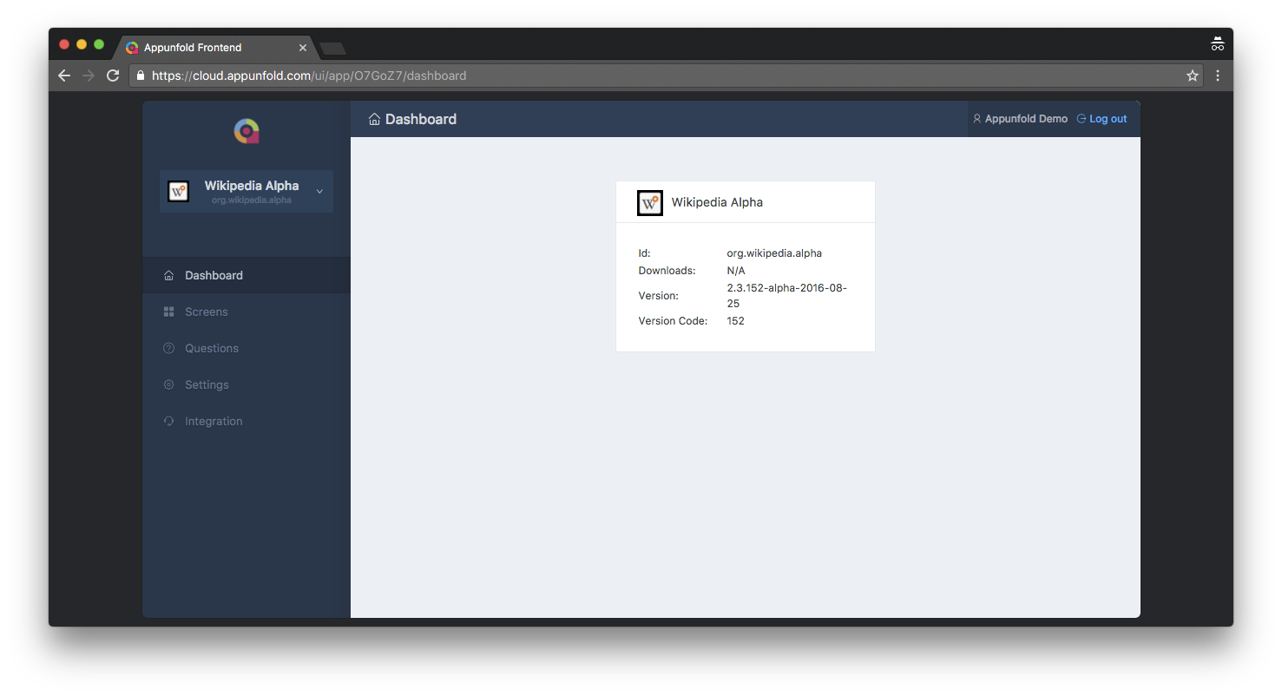

1. View all your Q&A’s in the Questions page. You can also create questions from this page. To create questions click on **New Question.**

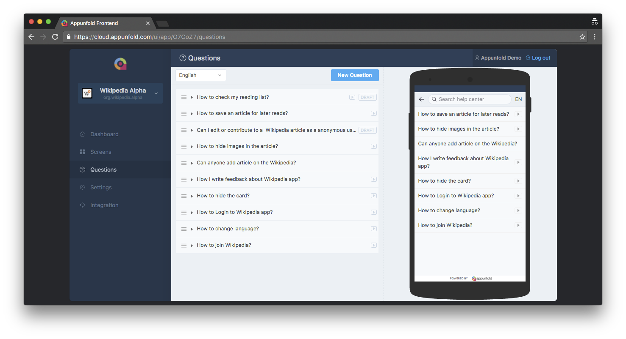

1. Add the question and answer and click **Save**. This will create only contextual FAQs. To create walkthrough click on **Add Screen** just below the answer.

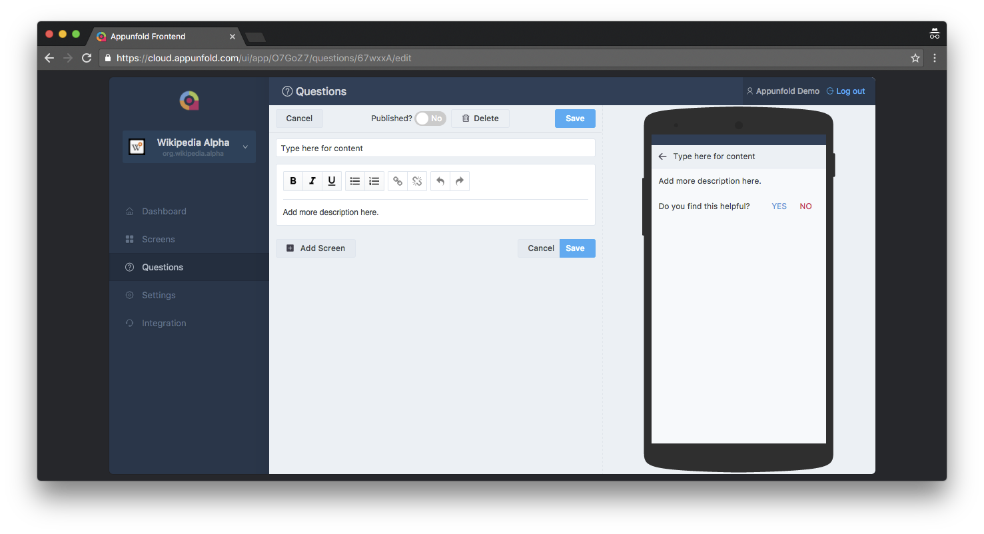

1. Add images for the walkthrough you want to create and select any part of the image. Add title, description, audio (optional) and click on **OK.** Do the same for other images and click on **Save**. This will save the walkthrough.

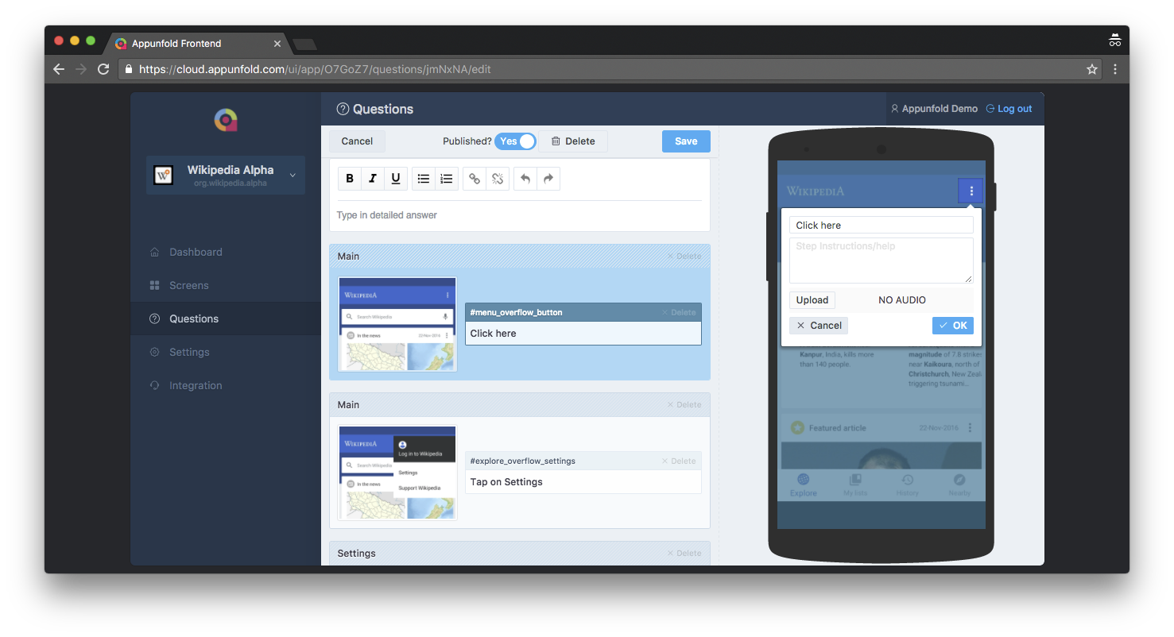

## Appunfold Production SDK Installation

1. Get the API Key from the Integration page of your dashboard.

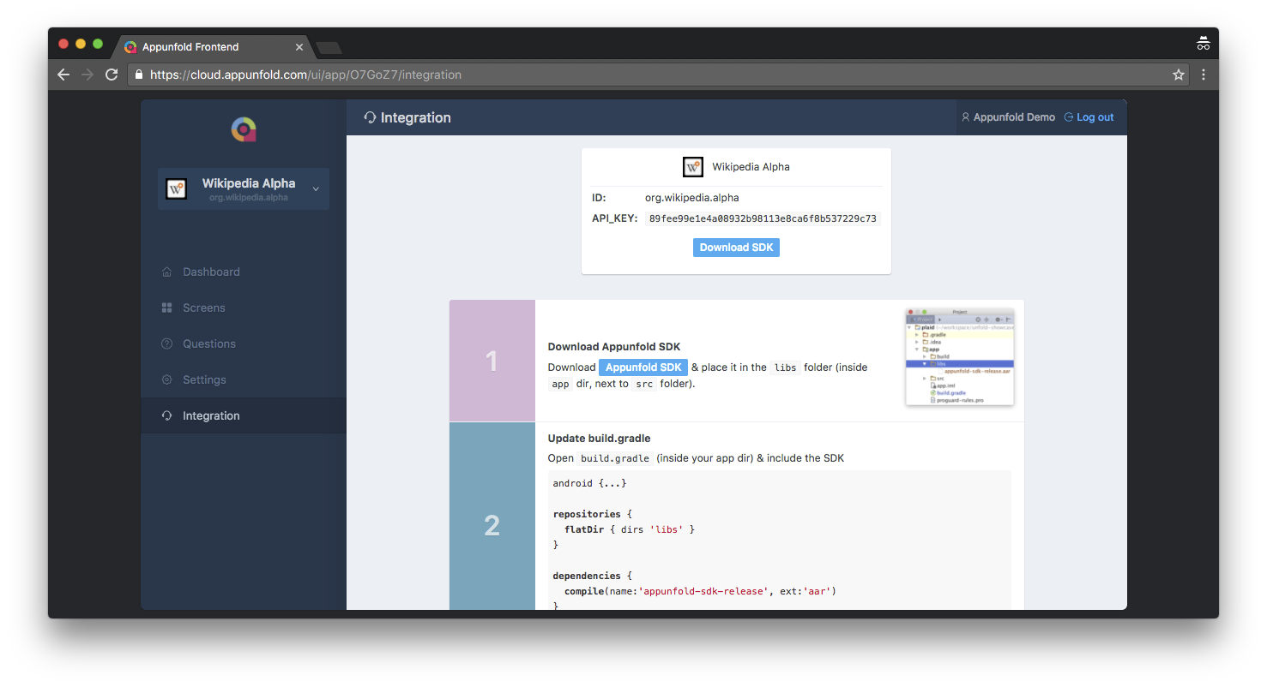

1. Open build.gradle and include the SDK

|  |
| --- |
| In the module/app level  --------------------  android {...}  dependencies {  compile '**com.appunfold:sdk:1.0.8**'  }  In the root level  --------------------  allprojects {  repositories {  maven {  url "**http://dl.bintray.com/appunfold/android**"   }  jcenter()  }  } |

1. Initialise SDK
2. Create your custom Application class by extending **android.app.Application** ( Skip to step B if you already have a custom application. )

* Add it to the manifest.

|  |
| --- |
| <**application**  **android:name="com.example.MyApplication"**>  </**application**> |

1. Update your custom Application class

* Open up your custom Application (eg. **class MyApplication extends android.app.Application**)
* Initialize AppunfoldSDK by including following lines in onCreate() method of MyApplication

|  |
| --- |
| public class MyApplication extends Application {  @Override  public void onCreate() {  super.onCreate();  **AppunfoldSDK.*init*(this, "API-KEY");**  }  } |

## Appendix

### Access HelpCenter from your Menu

For apps who do not want a floating Fab button, you can access HelpCenter from a menu.

1. If your menu is inside an activity, call this method from where you want to invoke.

**AppunfoldSDK.**showHelpCenter**(this);**

*or*

1. If your menu is inside a fragment, use this:

**AppunfoldSDK.**showHelpCenter**(**getActivity()**);**

### Mapping per-user analytics

To gather user-level analytics, use this API. This API identifies individual users and maps corresponding analytical data. (AppunfoldSDK must initialised before you call this method.)

**AppunfoldSDK**.*getUser*()

.setId(**"EMP124"**)

.setEmail(**"arnold@appunfold.com"**)

.setName(**"Arnold"**)  
 .addParam(**"Role", “DELIVERY”**)

.addParam(**"Location", “Bangalore”**)

.save();

**Note:** All the parameters are optional. If you need to add more parameters use addParam(**"key",“value”**)

1. Quiz Integration

Include the AppunfoldQuiz SDK in your build.gradle.

dependencies {

compile '**com.appunfold:quiz:1.0.1**'

}

For launching quiz from your app, add the line of code mentioned below

**AppunfoldQuiz.launch(context);**

1. Proguard Configuration

For releasing your app in production, If Proguard is enabled in your app, include the following in the app's **proguard-rules.pro**

-keep class com.appunfold.**

## Troubleshooting

1. Dependency on RecyclerView and CardView

Appunfold SDK depends on support library of RecyclerView and CardView with *version 23.4.0* and higher. Normally, this is automatically taken care by Android Studio and Manifest Merger, but for apps that have dependency on older support libraries, make sure that your support library dependencies are updated to 23.4.0 or greater.

dependencies {

...

compile **'com.android.support:cardview-v7:23.4.0'**

compile **'com.android.support:recyclerview-v7:23.4.0'**

compile **'com.appunfold:sdk:1.0.6'**

...

}